October 14,
2021

Community Center’s SeniorConnect fundraiser gains contributions from local banks
The La Jolla Community Center’s SeniorConnect fundraiser to build a new computer lab at the center has garnered contributions of $2,500 each from OneWest Bank and Pacific Western Bank in La Jolla. With the banks’ contributions, LJCC will begin buying equipment for the new space.
The SeniorConnect project launched earlier this year and will continue through February. All contributors will be honored at LJCC’s Health/Tech Fair slated for Feb. 11.
For more information, visit ljcommunitycenter.org/seniorconnect.
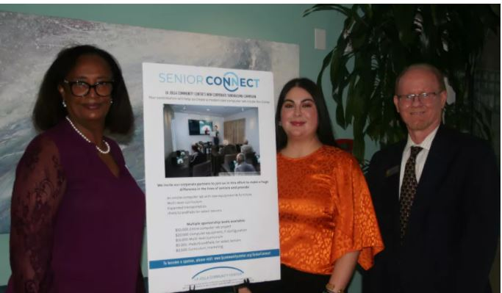

Kedest Berhanu, assistant vice president and branch operations manager at Pacific Western Bank, Nancy Walters, executive director of the La Jolla Community Center, and Jeff Lenhoff, vice president and branch manager at OneWest Bank (from left), mark the banks’ contributions toward a new computer lab at the center.
(Courtesy of La Jolla Community Center)

