Thursday,
October 6,
2021

County supervisor issues proclamation to La Jolla Community Center
During a meet-and-greet at the La Jolla Community Center on Sept. 19, San Diego County Supervisor Terra Lawson-Remer, whose District 3 includes La Jolla, issued a proclamation honoring LJCC for its “outstanding leadership and service to our community.”
The proclamation also states that the center has a “long history of leadership, involvement and investment in La Jolla” and is “committed to enhancing the lives of adults and the growing senior population.”
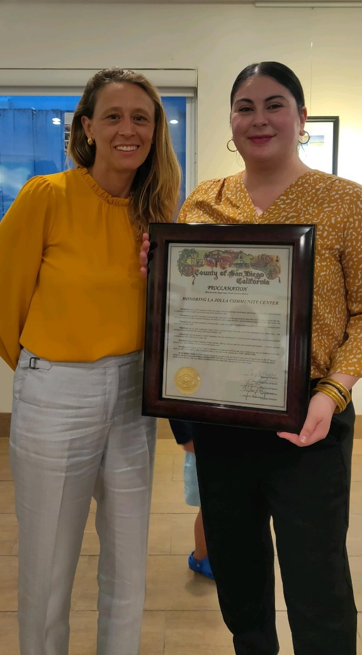

San Diego County Supervisor Terra Lawson-Remer (left) presents a proclamation
to La Jolla Community Center Executive Director Nancy Walters.

