2/15/2022

‘A laboratory on the skin’: UC San Diego lab works to make new wearable health sensors part of our daily look
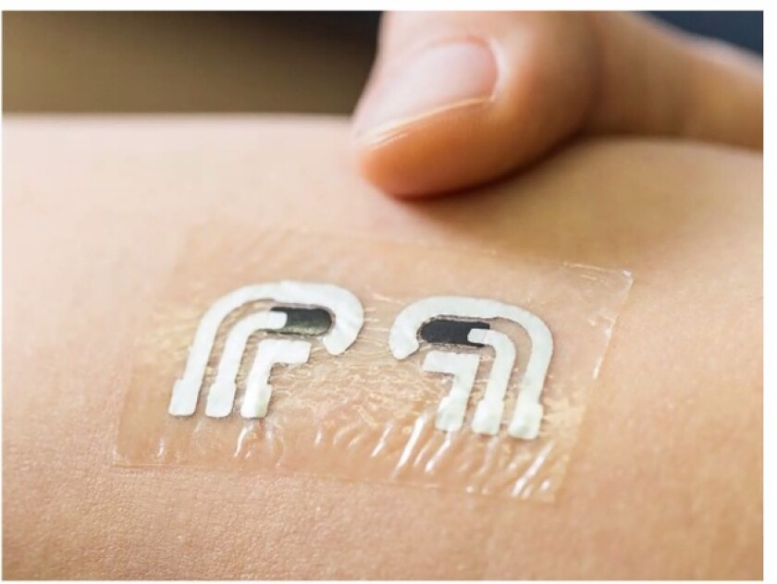

Health-monitoring sensors wearable on the skin are being developed in the lab of UC San Diego professor Joseph Wang. (Courtesy of Joseph Wang)

BY ELISABETH FRAUSTO
STAFF WRITER
FEB. 15, 2022 8 AM PT
Wearing a small patch that monitors health information may soon become as much a part of our daily routines as putting on clothes, a UC San Diego professor believes.
Joseph Wang, who works in UCSD’s Department of Nanoengineering and directs its Center for Wearable Sensors, said during a Feb. 8 virtual lecture presented by the La Jolla Community Center that we might be only months away from wearing “a laboratory on the skin.”
Wang detailed his work in “striving to meet the challenges of developing the next generation of wearable sensors,” noting that such sensors have come a long way from the rigid, invasive devices that have been around for decades.
The sensors developed by Wang’s lab are small, lightweight, flexible, patch-like devices that appear similar to temporary tattoos and follow his vision to “shrink a big laboratory” onto the skin.
As health care moves further into precision medicine — tailoring diagnostics or therapeutics based on patients’ genetic and physiologic characteristics — wearable sensors can be a key tool, he said.

UCSD nanoengineering professor Joseph Wang says he is “striving to meet the challenges of developing the next generation of wearable sensors.”
(Courtesy of La Jolla Community Center)
The highly sensitive electrochemical sensors that Wang’s lab has developed are an evolution from current devices worn around the wrist or finger to track mobility and vital signs like heartbeat.
“What was missing is the molecular information,” such as glucose, cortisol or electrolyte levels, Wang said.
His lab has worked on collecting that information continuously, non-invasively and digitally. The new wearable sensors also are made to be low-cost, with low energy use. The technology likely will be licensed, with prices set by local companies.
Wang said he has worked on various prototypes, all of which analyze body fluids for “different molecular biomarkers” to monitor nutrition and wellness.
Most types of sensors worn on the skin measure components in the sweat, he said. “The skin is the gateway to … our biochemistry.”

