9/3/2021

Community Center’s new exhibit honors late
member and her art

Mimi Guarneri, Anne Michelle Casco, Marjorie Nass, Ruth Yansick and Nicole Caulfield (standing, from left) and Martin Nass attend a Sept. 26 reception for a new La Jolla Community Center exhibit featuring the artwork of the late Marilyn Nass.
(Courtesy of La Jolla Community Center)
The La Jolla Community Center held a reception for the opening of an exhibit of Marilyn Nass’s paintings Sept. 26. Nass, a La Jolla resident from 2014 until her death in 2020, began painting through lessons at LJCC the last year of her life, taking many of the offered classes via Zoom during the early months of the COVID-19 pandemic.
The reception for the exhibit, “Celebrating the Life and Paintings of Marilyn L. Nass,” showed several of her paintings as Nass’s husband, Martin, and Jack Clausen and Willis Frisch played chamber music.
Nicole Caulfield, Marilyn Nass’s painting instructor, said she had a “conscious and intuitive approach to painting. She had what seemed to be an inner compass guiding her work from start to finish.”
After Nass’s death, LJCC and its chief executive, Ruth Yansick, established the Marilyn Nass Creative Arts Fund to enable more senior citizens to have access to arts opportunities.
The Nass exhibit will run through Wednesday, Oct. 6. Reservations are required. To learn more, visit ljcommunitycenter.org.

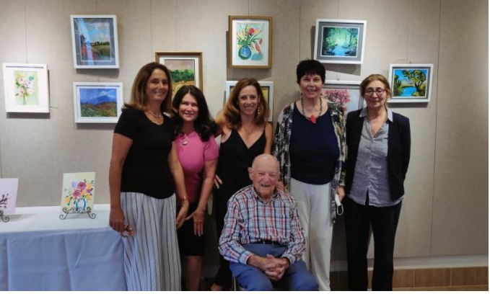
Mimi Guarneri, Anne Michelle Casco, Marjorie Nass, Ruth Yansick and Nicole Caulfield (standing, from left) and Martin Nass attend a Sept. 26 reception for a new La Jolla Community Center exhibit featuring the artwork of the late Marilyn Nass.
(Courtesy of La Jolla Community Center)

