Tuesday,
November 8,
2022

Photo gallery: La Jolla has a lively celebration of Day of the Dead
The La Jolla Community Center held its Day of the Dead (Dia de los Muertos) party Nov. 2 to commemorate the Mexican holiday.
The event featured face painting and sugar skull decorating, live mariachi music and a traditional Mexican dinner.

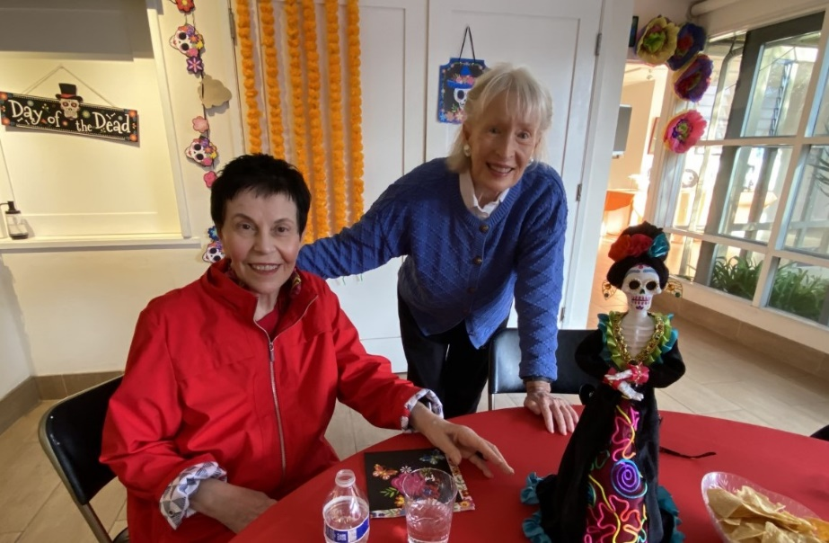

Ruth Yansick, CEO and Leanne MacDougall

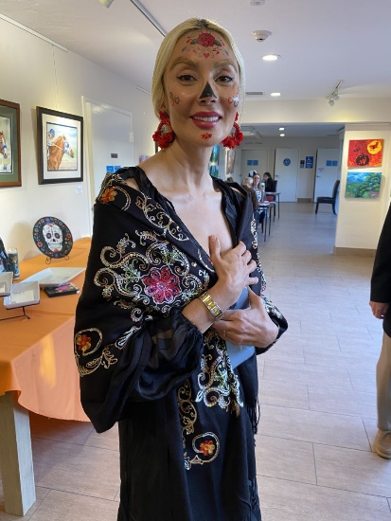

Symphony Moussighi, LJCC board of director with face painting.

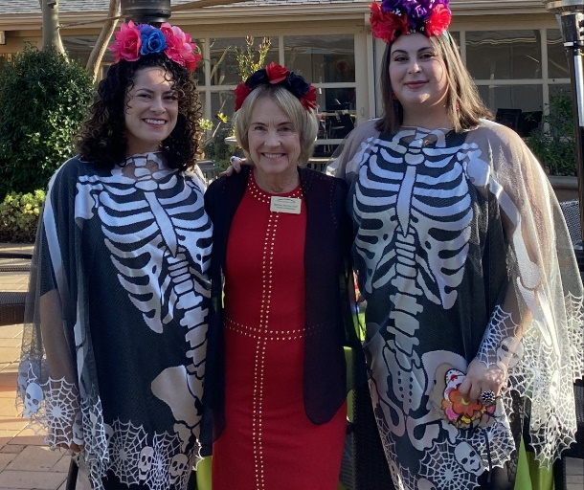

Deborah Miller, Barbara Graf and Nancy Walters.

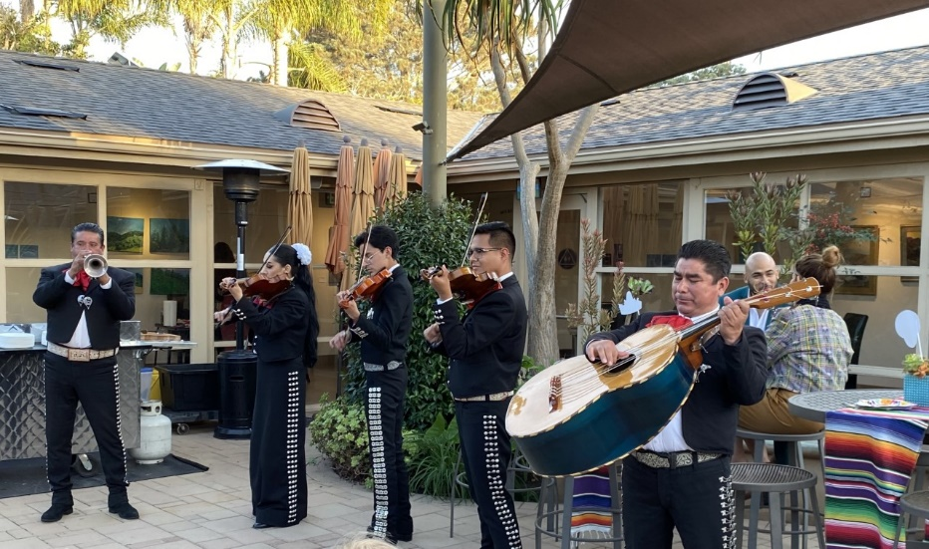

Mariachi Juvenil Azteca Band

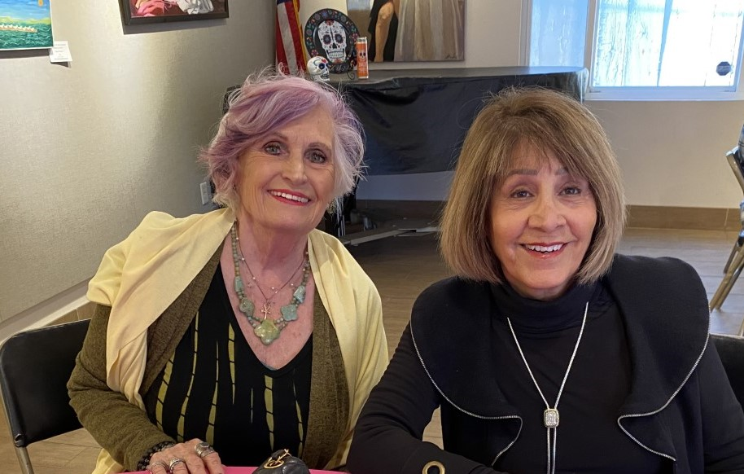

Sheri McColley and Bassie Kanon

