6/16/2022 | Social Life
Photo gallery: La Jolla Community Center flamenco performance takes guests on ‘A Night in Sevilla’

JUNE 13, 2022 10 AM PT
The La Jolla Community Center hosted “A Night in Sevilla” on June 3 with about 100 people gathered for refreshments and performers from the Flamenco Sur Dance Company, along with music by Reyes Barrios and Kambiz.
The event was sponsored by The Cove at La Jolla, White Sands La Jolla, Atria La Jolla and Arosa Home Care.
For more information about the La Jolla Community Center, visit ljcommunitycenter.org.

A total of 17 Photos was included in the 2-page spread. Representative photos below:

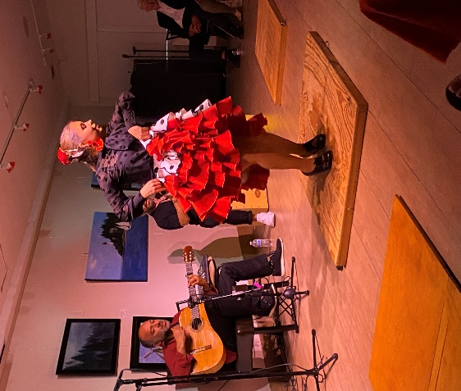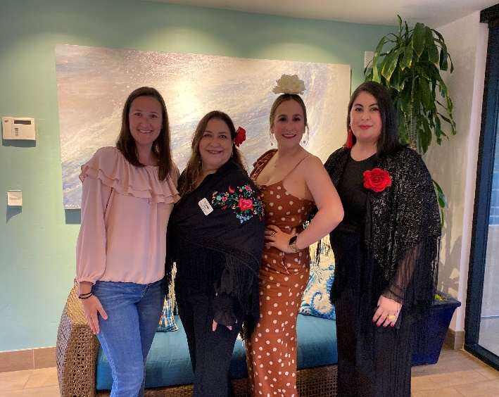

Photo on L: Flamenco dancer with the Sur Dance Company; Photo on R: from L to R: Jennifer Knox, administrator for The Cove at La Jolla; Yolanda Valencia, community outreach liaison at White Sands La Jolla; Hilla De Anda, marketing director at the Cove; and Nancy Walters, executive director of the La Jolla Community Center.

